**Semester Two**

**Examination 2023**

**Marking Guide**

**BIOLOGY**

**UNITS 3 & 4**

Name: _______________________________________________________

Teacher: ___________________________________________________

***TIME ALLOWED FOR THIS PAPER***

Reading time before commencing work: Ten minutes

Working time for the paper: Three hours

***MATERIALS REQUIRED/RECOMMENDED FOR THIS PAPER***

**To be provided by the supervisor:**

* This Question/Answer Booklet.

**To be provided by the candidate:**

* Standard items: Pens, pencils, eraser or correction fluid, ruler, highlighter.
* Special items: Calculators satisfying the conditions set by the SCSA for this subject.

***IMPORTANT NOTE TO CANDIDATES***

No other items may be taken into the examination room. It is **your** responsibility to ensure that you do not have any unauthorised notes or other items of a non-personal nature in the examination room. If you have any unauthorised material with you, hand it to the supervisor **before** reading any further

**Structure of this paper**

|  |  |  |  |  |  |
| --- | --- | --- | --- | --- | --- |
| Section | Number of questions available | Number of questions to be answered | Suggested working time  (minutes) | Marks available | Percentage of exam |
| Section One:  Multiple-choice | 30 | 30 | 40 | 30 | 30 |
| Section Two:  Short answer | 5 | 5 | 90 | 100 | 50 |
| Section Three  Extended answer | 2 | 1 | 50 | 20 | 10 |
|  | 2 | 1 |  | 20 | 10 |
|  |  |  | **Total** | 200 | 100 |

**Instructions to candidates**

1. The rules for the conduct of the Western Australian external examinations are detailed in the *Year 12 Information Handbook 2023: Part II Examinations.* Sitting this examination implies that you agree to abide by these rules.
2. Write your answers in this Question/Answer booklet preferably using a blue/black pen. Do not use erasable or gel pens.
3. Answer the questions according to the following instructions.

Section One: Answer all questions on the separate Multiple-choice answer sheet provided. For each question, shade the box to indicate your answer. Use only a blue or black pen to shade the boxes. Do not use erasable or gel pens. If you make a mistake, place a cross through that square, then shade your new answer. Do not erase or use correction fluid/tape. Marks will not be deducted for incorrect answers. No marks will be given if more than one answer is completed for any question.

Section Two: Write your answers in this Question/Answer booklet. Wherever possible, confine your answers to the line spaces provided.

Section Three: Consists of two parts each with two questions. You must answer one question from each part. Tick the box next to the question you are answering. Write your answers in this Question/Answer booklet.

1. You must be careful to confine your answers to the specific questions asked and to follow any instructions that are specific to a particular question.
2. Supplementary pages for planning/continuing your answers to questions are provided at the end of this Question/Answer booklet. If you use these pages to continue an answer, indicate at the original answer where the answer is continued, i.e. give the page number.

**Section One: Multiple-choice 30% (30marks)**

|  |  |
| --- | --- |
| Question | Answer |
| 1 | a |
| 2 | d |
| 3 | d |
| 4 | c |
| 5 | a |
| 6 | b |
| 7 | d |
| 8 | a |
| 9 | b |
| 10 | b |
| 11 | b |
| 12 | a |
| 13 | c |
| 14 | d |
| 15 | a |
| 16 | c |
| 17 | b |
| 18 | b |
| 19 | d |
| 20 | b |
| 21 | d |
| 22 | a |
| 23 | b |
| 24 | c |
| 25 | b |
| 26 | d |
| 27 | c |
| 28 | a |
| 29 | d |
| 30 | b |

**Section Two: Short answer**

This section has **five** questions. Answer **all** questions. Write your answers in the spaces provided.

Supplementary pages for planning/continuing your answers to questions are provided at the end of this Question/Answer booklet. If you use these pages to continue an answer, indicate at the original answer where the answer is continued, i.e. give the page number.

Suggested working time: 90 minutes.

**_________________________________________________________________________**

**Question 31 (19 marks)**

The H5N1 bird flu virus had spread to all continents except Australia and Antarctica by February 2023. In the twelve-month period between March 2022 and February 2023 H5N1 caused the death of half a billion domestic and agricultural poultry birds. Furthermore, H5N1 moved between species and infected countless wild birds and at least seventeen mammal species, these including mink, foxes, otters, seals, bears, mountain lions and skunks.

1. Describe two structural features that can distinguish virus from protists. (4 marks)

|  |  |
| --- | --- |
| **Description** | **Marks** |
| Virus have a protein coat/capsid (1)  Protists have cell membranes/some have cell walls (1) | 2 |
| Virus have no membrane bound organelles (1)  Protists have membrane bound organelles (1) | 2 |
| Virus have no nucleus surrounding genetic material(1)  Protists have a nucleus surrounding genetic material (1) | 2 |
| Virus are 30 – 300 nanometres in lengthMuch smaller (1) than protists 2-1000 micrometers. (1) **MAX 1 FOR THIS PAIR IF NO UNITS** | 2 |
| **ANY 2 pairs Total** | **4** |

1. While most bird flu viruses have low pathogenicity H5N1 has high pathogenicity.

Define ‘pathogenicity’. (1 mark)

|  |  |
| --- | --- |
| **Description** | **Marks** |
| The capacity of a pathogen to cause disease in a host. | 1 |
| **Total** | **1** |

1. (i) Explain if H5N1 is zoonotic. Support your answer with an example. (3 marks)

|  |  |
| --- | --- |
| **Description** | **Marks** |
| * It is zoonotic. | 1 |
| * The disease has moved from one vertebrate species to another vertebrate species. * Provides a suitable example - other bird species than domestic hens, mammals, amphibian, reptile, fish | 1-2 |
| **Total** | **3** |

(c) (ii) Explain if H5N1 is endemic, epidemic, or pandemic. (2 marks)

|  |  |
| --- | --- |
| **Description** | **Marks** |
| * Pandemic | 1 |
| * Has spread rapidly across much of the world/international borders. | 1 |
| **Total** | **2** |

1. Provide **two** explanations for Australia and Antarctica remaining free of the H5N1 virus by February 2023. (4 marks)

|  |  |
| --- | --- |
| **Description** | **Marks** |
| * High levels of quarantine. * An infected bird, animal (or person) has not been able to enter via a port/airport. | 1-2 |
| * Australia and Antarctica are isolated land masses. * Birds that enter Australia/Antarctica would have to fly a long way and are likely to die on route if diseased. | 1-2 |
| Or other suitable and thorough explanations that cover **both** Australia **and** Antarctica. | 1-2 |
| **Total** | **4** |

Should H5N1 arrive in Australia, vaccination may be used to reduce spread between poultry in agricultural and hobby farms.

(e) Discuss the potential impacts of an agricultural and hobby farm-based vaccination program on wild bird species. (5 marks)

|  |  |
| --- | --- |
| **Description** | **Marks** |
| * Wild birds would not be vaccinated. * Wild birds would remain at risk of contracting H5N1. * This would result in many deaths of wild birds.   **NOT MUCH REFERENCE TO WILD BIRDS, MAIN POINT OF QUESTION** | 1-3 |
| * A comprehensive vaccination programme may reduce the prevalence of the virus.   OR   * A comprehensive vaccination programme may reduce the number of possible hosts.   OR   * This may result in some herd immunity in areas with high vaccination levels. * Reducing the spill over into wild bird species. | 1-2 |
| **Total** | **5** |

**Question 32 (20 marks)**

Malignant hyperthermia (MH) is a rare and inheritable gene mutation. Whilst most common in Greyhounds, the life-threatening disorder has also been observed in Pointers, Labradors, Saint Bernards, Springer Spaniels, Bichon Frises, Golden Retrievers and Border Collies.

Advances in DNA technologies enable dogs to be genetically tested for MH. Extensive gene genetic testing has been carried out in the following Greyhound family. Animals identified as suffering from MH are shaded.

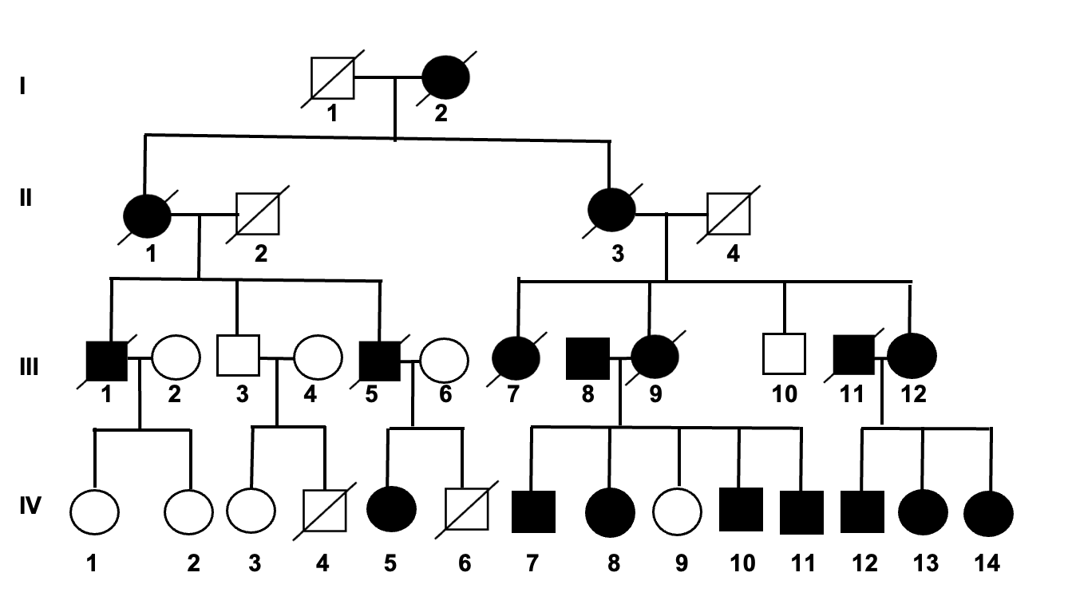

1. Explain how sex is inherited in puppies. (4 marks)

|  |  |
| --- | --- |
| **Description** | **Marks** |
| * Female has XX sex chromosomes; female always passes an X chromosome into her gametes. * Male has XY; male gametes contain X or a Y chromosome. * Female puppies inherit an X from both parents. * Male puppies inherit an X and a Y, with the X coming from the mother’s gamete and the Y from the father’s gamete.   If student has shown answer in punnett square, check to see if the above detail is shown and mark accordingly. | 1-4 |
| **Total** | **4** |

**MAX 3 IF NO MENTION OF GAMETES**

1. Explain if MH is most likely dominant or recessive. (4 marks)

|  |  |
| --- | --- |
| **Description** | **Marks** |
| * Dominant | 1 |
| **Any three of the following**   * There is no evidence of MH skipping generations. * IV 9 is unaffected by the disease. * IV 9 has inherited the recessive unaffected allele from each of her carrier parents (III 8 and III 9). * III 8 and III 9 are both affected and must both be carriers/heterozygous/hybrid. | 1-3 |
| **Total** | **4** |

**LOTS OF PEOPLE SKIPPING THE DETAIL HERE**

1. Explain if MH is most likely an autosomal or sex lined trait. (4 marks)

|  |  |
| --- | --- |
| **Description** | **Marks** |
| * Autosomal | 1 |
| * If it was X linked, you would expect to see a higher level of MH in males. * Almost equally common in males and females - 8 males have been affected and 9 females. * If it was X linked dominant, you would see affected father transmitting it to all his daughters – this is not the case – see III-1. | 1-3 |
| **Total** | **4** |

**MORE EVIDENCE NEEDED HERE**

1. Assume that IV 3 and III 8 were crossed. What is the chance the first-born puppy of this cross will be an affected female puppy? (Show all working.) (4 marks)

|  |  |
| --- | --- |
| **Description** | **Marks** |
| * Mother/IV 3 is homozygous recessive genotype. Father/III 8 is heterozygous. * Working out is shown in a punnet square.   For example, where M and m are the alleles (students may choose different letters)   |  |  |  | | --- | --- | --- | |  | m | m | | M | Mm | Mm | | m | mm | mm |  * Chance of an affected puppy is ½ OR 0.5 OR 1 in 2. * **The chance of an affected female puppy is ½ x ½ = ¼ OR 0.25 OR 1 in four** | 1-4 |
| **Total** | **4** |

**PAID FOLLOW THROUGH IF DID NOT PICK CORRECT INHERITANCE PATTERN**

MH is caused by a mutation that leads to alanine replacing valine at one specific location in the protein.

1. Explain why a slightly different protein was produced. (4 marks)

|  |  |
| --- | --- |
| **Description** | **Marks** |
| * A point mutation OR missense mutation OR gene mutation occurred in one triplet of the gene. * The altered triplet altered the codon on the mRNA. * The codon has one (or more) different base(s) than that which would have coded for valine. * Translation results in alanine being put in this place instead valine, and in response the polypeptide/primary protein is different. | 1-4 |
| **Total** | **4** |

**REFER TO CONTEXT IN QUESTION**

**Question 33 (24 marks)**

Year Twelve biology student, Bertie Roach conducted an experiment. Bertie was keen to understand the alleles that determined beetle antennae length and how the frequency changed over time.

Bertie kept his beetles in a closed container and provided sufficient resources to maintain the population at 10 adult beetles. At the end of each generation, Bertie took a small sample of cellular material from each beetle and completed genetic analysis, this allowing him to determine genotypes.

The genotype data that was collected over five consecutive generations is presented below. Each rectangle represents one beetle.

|  |  |  |  |  |
| --- | --- | --- | --- | --- |
| Generation | Genotypes of individuals in population | Population size | Frequency ‘N’  allele  (%) | Frequency ‘n’  allele  (%) |
| 1 | Nn  Nn  NN  NN  NN  Nn  Nn  nn  nn  nn | 10 | 50 | 50 |
| 2 | NN  NN  NN  NN  NN  Nn  Nn  nn  nn  nn | 10 | 60 | 40 |
| 3 | NN  NN  NN  NN  NN  Nn  NN  Nn  Nnn  Nn | 10 | 80 | 20 |
| 4 | NN  NN  NN  NN  NN  NN  NN  NN  Nn  Nn | 10 | 90 | 10 |
| 5 | NN  NN  NN  NN  NN  NN  NN  NN  NN  NN | 10 | 100 | 0 |

1. (i) Complete the table by calculating the ‘N’ and ‘n’allele frequencies. (3 marks)

|  |  |
| --- | --- |
| **Description** | **Marks** |
| Any six of: |  |
| See above.  1 - 2 correct = 1 mark  3 - 4 correct = 2 marks  5 - 6 correct = 3 marks | 1-3 |
| **Total** | **3** |

(ii) Identify the range of the ‘N’ allele frequency over the five generations. (1 mark)

|  |  |
| --- | --- |
| **Description** | **Marks** |
| * 50% for both N and n. | 1 |
| **Total** | **1** |

1. Graph the frequency of the alleles against generation number. (6 marks)

|  |  |
| --- | --- |
| **Description** | **Marks** |
| Remove a mark if any of the following are missing or incorrect |  |
| * Correct axes - X axis - generation number,   Y axis – frequency of allele as %   * Correct axis labelling. * Correct use of scale. * Correct units (n) and (%) * Title - Independent and dependent variables - for example “Graph showing change in frequency (%) of N and n alleles withing a population over 5 generations.” * Point plotting is correct. * Provides a key.   **The data is discrete – Discrete data is generally graphed as columns. (A sectioned column graph is also appropriate).**  **-1 OF LINE GRAPH** | 1-6 |
| **Total** | **6** |

An example of a possible column graph.

1. (i) State the independent variable for the investigation. (1 mark)

|  |  |
| --- | --- |
| **Description** | **Marks** |
| * Generation (no units needed generation fine and above) | 1 |
| **Total** | **1** |

1. Identify **three** variables Bertie should have controlled while running the experiment. (3 marks)

|  |  |
| --- | --- |
| **Description** | **Marks** |
| Any three of the following or another valid controlled variable |  |
| * Size of container. * Quantity of food. * Quantity of water. * Cleanliness of container. + any reasonable control that wasn’t already controlled eg species of beetle | 1-3 |
| **Total** | **3** |

At the end of the experiment Bertie concluded that natural selection had been observed in action.

1. Explain how natural selection could have changed the allele frequencies in the beetle population. (6 marks)

|  |  |
| --- | --- |
| **Description** | **Marks** |
| Any six of: |  |
| * **1.Variation** in the population – N and n/ antennae length. * **2.Over production** – all beetles had more offspring than could survive. * **3.Selection pressure** – for example the use of antennae to detect food faster than other beetles. This   ***This idea required an example of a selection pressure that may affect beetles and their antennae length****.*   * 4.This led to **competition,** for example those with NN or Nn outcompeted those with nn. * 5.More beetles with N survived – survival of the **fittest.** * 6.Those with N were more **successful in reproduction** and passing on their genes to the next generation. * **7.Allele frequencies change** - In response there was an increase in N over time. | 1-6 |
| **Total** | **6** |

***Most students achieved 3 or 4 out of 6, saying points 1, 4 – 7. This was a tricky question because you didn’t know whether long antennae or short antennae was represented by N or n allele.***

Bertie’s classmate, Bertha, suggested an alternate explanation for the data.

1. Provide the alternate explanation for the changes in allele frequencies in the beetle population. (4 marks)

|  |  |
| --- | --- |
| **Description** | **Marks** |
| * 1.Genetic drift * 2.Can lead to fixation of one allele over another. * 3.Over a relatively short time/number of generations/ is very significant in small population. * 4.Genetic drift is a result of chance events.   OR   1. Sexual selection 2. Individuals with longer antennae are more likely to reproduce (or vice versa) 3. Greater frequency of N alleles passed onto next generation 4. But longer antennae do not benefit survival – make it more difficult to move around (or other reasonable example) | 1-4 |
| **Total** | **4** |

**Question 34 (20 marks)**

Sea kraits are a lineage of venomous semi-aquatic snakes. They are oviparous creatures, meaning they lay eggs which develop and hatch outside the body.

A marine environment places water and salt stresses on sea kraits.

1. (i) Identify the **two** osmotic stresses experienced by sea kraits when in marine

environments. (2 marks)

|  |  |
| --- | --- |
| **Description** | **Marks** |
| * Salts move into the sea krait’s body. * Freshwater leaves the sea krait’s body. | 1-2 |
| **Total** | **2** |

(ii) Explain how a sea krait could overcome each of osmotic stress. (4 marks)

|  |  |
| --- | --- |
| **Description** | **Marks** |
| Sea krait must actively excrete salts from the body. | 1 |
| Provides a suitable mechanism such as a   * Salt gland (behind the eye).   **OR**   * Production of a small volume of a very salty waste from kidneys. | 1 |
| Sea krait must uptake water/ increase water gain. | 1 |
| Provides a suitable mechanism such as   * + - Consuming salt water (and removing salt from this water).   **OR**   * + - Finding a source of freshwater and drinking this. | 1 |
| **Total** | **4** |

Consider the nephrons within the kidney of a sea krait.

1. In the table below identify **two** structural characteristics that would be observable in the nephron of a sea krait. In the second column explain the advantage of the characteristic. (4 marks)

|  |  |
| --- | --- |
| **Description** | **Marks** |
| |  |  |  | | --- | --- | --- | |  | Characteristic | Advantage of characteristic | | Characteristic  1 | Long Loop of Henle. | Provides a large surface area for reabsorption of water into blood/ from filtrate. | | Characteristic  2 | High degree of vascularisation/lots of capillaries wrapped around tubule | Allows for active secretion and reabsorption. | |  | Small glomeruli | Decreased rate of filtration – smaller volume of urine produced | | 1-4 |
| **Total** | **4** |

A team of biologists completed research on three species of sea krait.

They captured and used:

* Ten *Laticauda colubrina.*

(Five were used as controls and five were used for the test group).

* Six *Laticauda laticaudata.*

(Three were used as controls and three were used for the test group).

* Fourteen *Laticauda semifasciata.*

(Seven were used as controls and seven were used for the test group).

Each sea krait had its mass recorded at the beginning of the experiment and then every three days across the 36-day research period.

The control groups were kept in sea water throughout the experiment. The test groups were kept in sea water for the duration of the experiment however for one hour prior to being weighed each test sea krait was placed in fresh water. Immediately after weighing, each of the test sea kraits were returned to sea water.

Following analysis of their data, the researchers produced the graph below.

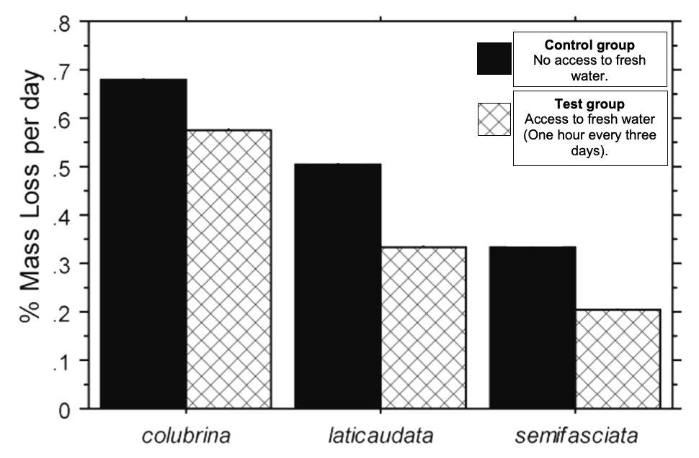

1. (i) State **one** hypothesis that was being tested. (2 marks)

|  |  |
| --- | --- |
| **Description** | **Marks** |
| **An example**  Individuals from three sea krait species that have access to fresh water will lose a lower percentage of body mass on daily basis than individuals of the same species that only access sea water.  Must be written as a:   * Cause/effect statement - Links % of mass lost to being dependent on **access to fresh water. *(max of 1 mark if IV is given as the species)*** * Testable statement. | 1-2 |
| **Total** | **2** |

1. Identify **two** conclusions that could be drawn from the data. (2 marks)

|  |  |
| --- | --- |
| **Description** | **Marks** |
| One mark for each suitable conclusion that can be directly drawn from data. Two examples are below.   * In all cases, the sea krait kept in sea water lost more mass per day than those that had one hour every three days in fresh water. ***(Must refer to the IV not just control group and test group)*** * *Laticauda colubrina* lost the most percentage mass over the 36-day period, followed by *Laticauda laticaudata and then Laticauda semifasciata.* | 1-2 |
| **Total** | **2** |

1. Give **one** explanation for the data. (2 marks)

|  |  |
| --- | --- |
| **Description** | **Marks** |
| Two marks for a thorough explanation of the data.  An example is shown below.   * The sea kraits that can access fresh water will drink. * In so doing, the sea kraits reduce the effects of dehydration.   OR   * Sea krait are in a hypotonic environment when in fresh water/ snake is hypertonic to its environment * Causing water to move into snake via osmosis – causing it to gain back some water previously lost | 1-2 |
| **Total** | **2** |

1. (i) Evaluate the reliability of the data. (2 marks)

|  |  |
| --- | --- |
| **Description** | **Marks** |
| * Small sample sizes reduce the reliability of the data. * Particularly for *Laticauda semifasciata*, where there were only three in the test and three in the control groups.   ***Some students mentioned this idea in relation to validity – it relates to the sample size so is relaibility***  OR   * No repetition of the data (allow one mark only if this is the only statement) | 1-2 |
| **Total** | **2** |

(ii) Evaluate the validity of the data. (2 marks)

|  |  |
| --- | --- |
| **Description** | **Marks** |
| * Validity is assisted by having test and control groups – this provides comparative data that allows the independent variable – access to fresh water - to be tested. * More information would assist with understanding of validity - would need to know if all other variables were controlled to be sure that the validity was high. | 1-2 |
| **Total** | **2** |

**Question 35 (17 marks)**

Wedge Tail Eagles are Australia’s largest bird of prey. They are found in most habitat types and have been known to migrate large distances.

1. (i) I Identify the main nitrogenous waste produced by Wedge Tailed Eagles. (1 mark)

|  |  |
| --- | --- |
| **Description** | **Marks** |
| * Uric Acid. | 1 |
| **Total** | **1** |

(ii) Explain **two** benefits for the Wedge Tailed Eagles associated with the use of the nitrogenous waste. (4 marks)

|  |  |
| --- | --- |
| **Description** | **Marks** |
| Any **two** of: |  |
| * 1.Non-toxic * 2.for both the adult and/or the young as they develop within the egg). | 1-2 |
| * 3.Wedge Tail Eagle can conserve water. * 4.Reduces risk of dehydration in arid terrestrial environments. | 1-2 |
| * 5.Wedge Tail Eagle can reduce the need to carry water as it is not needed to dilute a toxic waste product. * 6.Lower energy costs associated with flight. | 1-2 |
| **Total** | **4** |

A Wedge Tail Eagle’s diet consists of meat, this coming from birds, reptiles, and mammals. Food is captured when in flight or by scavenging of carcasses.

1. Explain the requirements associated with the eagle’s diet and nitrogenous waste production. (4 marks)

|  |  |
| --- | --- |
| **Description** | **Marks** |
| * 1.Diet high in protein. * 2.Leads to production of large amount of nitrogenous waste. * 3.Nitrogenous waste must be converted from ammonia 🡪 urea 🡪 uric acid (or ammonia 🡪 uric acid). * 4.Leads to a large need for ATP/high energy cost. | 1-4 |
| **Total** | **4** |

***Students often missed the 2nd idea and instead said that a diet high in protein has high energy to allow nitrogenous waste conversion to occur. This is not true – breaking down proteins creates nitrogenous wastes – so a diet high in protein makes more nitrogenous waste (initially as ammonia)***

Plants that survive in environments with little access to liquid water are known as xerophytes.

Xerophytes display a variety of structural adaptations. Two structural adaptations, A and B, have been identified on the Banksia marginata cross section shown below.

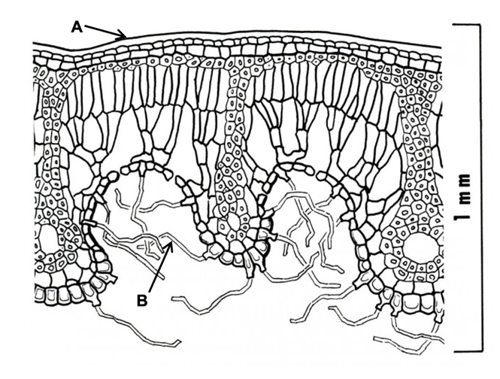

1. Explain how structures A and B assist xerophyte survival. (4 marks)

|  |  |
| --- | --- |
| **Description** | **Marks** |
| Structure A   * 1.Acts as a waterproofing layer/ impermeable barrier. * 2.Minimises water loss from within the plant to the surrounding air. | 1-2 |
| Structure B   * 3.Creates a zone of high humidity for water/traps vapour lost from stomata. * 4.**Decreases concentration gradient** between inside and outside of leaf, leading to less water is lost from the stomatal pores to the surrounding air. | 1-2 |
| **Total** | **4** |

Xerophytes also have physiological adaptations.

1. Identify and explain **two** physiological mechanisms used by xerophytes to minimise water loss. (4 marks)

|  |  |
| --- | --- |
| **Description** | **Marks** |
| Any **two** of the following sets |  |
| * 1.Plant moves potassium ions out of the guard cells, this leads to water moving out of guard cells and loss of stomatal pressure * 2.Closing of stomata. | 1-2 |
| * 3.Reversing the stomatal rhythm – Opening stomata at night rather than during the day * 4.Less water is lost to cooler night air than hotter daytime air. | 1-2 |
| * 5.Loss of water from plants cells within the leaf resulting in rolling of leaves. * 6.The stomata became trapped within the more humid environment and as a result lose less water to environment. | 1-2 |
| * 7.At the dry time of year, the hormone abscisic acid is produced leading to shedding of leaves. * 8.Reduces surface area for water loss. | 1-2 |
| * 9.Epidermal layer of leaf produces a thick waxy cuticle. * 10.This providing a waterproofing layer across the leaf. | 1-2 |
| * 11.Plant increases storage of salts within the body * 12.Results in an increases osmotic potential and more water is stored within leaves or stems OR water is less readily lost to the environment. | 1-2 |
| OR another suitably explained and thorough response that is **physiological** | 1-2 |
| **Total** | **4** |

**Section Three: Extended answer 20% (40 Marks)**

**Section Three: Extended answer 20% (40 Marks)**

Section Three consists of **four** questions.

Questions 36 and 37 are from Unit 3. Questions 38 and 39 are from Unit 4. Answer **one** question from Unit 3 and **one** question from Unit 4.

Use black or blue pen for this section. Do not use erasable or gel pens. Only graphs and diagrams may be drawn in pencil. Responses can include: labelled diagrams with explanatory notes; lists of points with linking sentences; labelled tables and/or graphs; and/or annotated flow diagrams with introductory notes.

Supplementary pages for planning/continuing your answers to questions are provided at the end of this Question/Answer booklet. If you use these pages to continue an answer, indicate at the original answer where the answer is continued, i.e. give the page number.

Suggested working time: 50 minutes.

**_________________________________________________________________________**

**Unit 3**Choose **either** Question 36 **or** Question 37.

Indicate the question you will answer by ticking the box next to the question. Write your answer on pages 27 to 31. When you have answered your first question, turn to page 32 and indicate on that page the second question you will answer.

**_________________________________________________________________________**

**Question 36 (20 marks)**

Over the past forty years there have been considerable advancements in DNA technologies. The advancements have included DNA profiling and DNA sequencing.

1. Provide a comparison of DNA profiling and DNA sequencing. (10 marks)

|  |  |  |  |  |
| --- | --- | --- | --- | --- |
|  | **Differences** | |  |  |
|  | DNA profiling | DNA Sequencing |  |  |
| Purpose | 1.Separate fragments of DNA by size to create a banding pattern (1) | 2.Determine the order of nitrogen bases in DNA (1) |  | 2 |
| Uses  (any 2 for each technique) | 3. Species ID (biosecurity)  4. Paternity/ maternity testing  5. Wildlife forensics | 6. Mapping genomes  7. Determining relatedness between species  8. Identifying gene mutations |  | 4 |
| Number of samples required | Minimum of 2 DNA samples required – relies on comparison on samples | Minimum of 1 DNA sample required |  | 2 |
| DNA used | Usually uses STRs which are non-coding DNA | Can sequence coding and non-coding DNA |  | 2 |
|  | **Total** | | **MAX** | **8** |

|  |  |
| --- | --- |
| **Description** | **Marks** |
| **Similarities** |  |
| Both techniques require:   * 11.Biological/cellular samples to be gathered and DNA to be extracted. * 12.PCR (polymerase chain reaction) ***so that DNA is amplified.*** * 13.Gel electrophoresis ***to separate the DNA.*** | 1-2 |
| Total MAX | 2 |

Every organism has a genome. For most species the genome contains many thousands of genes. Many of these genes contain information for protein production.

1. Explain how specific sections of an individual’s genome can result in the production of one protein. (10 marks)

|  |  |
| --- | --- |
| **Description** | **Marks** |
| * 1.Proteins are made of one or more polypeptides. * 2.Each polypeptide is coded for by the coding regions of the specific gene. | 1-3 |
| * 3.Coding region undergoes transcription OR DNA is used as a template to make the mRNA. * 4. RNA polymerase reads template/coding strand to build a complimentary strand of mRNA * 5.mRNA then undergoes maturation- intron removal/addition of methylated cap and poly A tail). * 6.Before leaving nucleus via nuclear pore. | 1-3 |
| * 7.Translation occurs in ribosomes * 8. mRNA codons are translated to a sequence of amino acids * 9.Transfer (t)RNA’s bring amino acids. * 10.Amino acids correspond to the mRNA codon. * Peptide bonds form between amino acids using ATP/energy * 11.Polypeptides, once folded and bonded together, make the functional protein. (Concept of primary structure, to secondary, tertiary or quaternary structure.) | 1-4 |
| **Total** | **10** |

**Question 37 (20 marks)**

Variation is of considerable importance to the evolution of organisms.

1. Discuss the factors that lead to variation within a population. (10 marks)

|  |  |
| --- | --- |
| **Description** | **Marks** |
| * 1.Permanent changes to the sequences of a gene, otherwise known as mutations. * 2.Introduce new alleles/variants into population. | 1-2 |
| * 3.Sexual reproduction remixes alleles/variants within the population. | 1 |
| * 4.Meiosis leads to 4 haploid cells from the original diploid cell. * 5.Crossing over - when homologous chromosomes exchange alleles * 6.Which occurs during prophase I * 7.Random segregation, the random alignment of homologous pairs/maternal and paternal chromosomes * 8.Which occurs during metaphase I * 9.As a result of crossing over and random segregation all four gametes are different combinations of the original parent cells genetic makeup. | 1-4 |
| * 10.Random fertilisation of the female gamete by one of a very large number of male gametes. | 1 |
| * 11.Achieved through outbreeding. * 12.Results in more significant variation when compared to population with high levels of inbreeding. | 1-2 |
| * 13.Gene flow can introduce new alleles to a population * 14. When individuals immigrate into a population | 1-2 |
| **Total** | **10** |

***Many students started off on the right track and then got off track and stated everything they knew about mutations. Take the time to identify the intent of the question and stay on track to save precious time.***

Significant technological advancements have also occurred in the fields of comparative genomics, comparative biochemistry, and bioinformatics.

1. Define comparative genomics, comparative biochemistry and bioinformatics. Explain how each field has enabled biologists to better understand evolutionary relationships between organisms. (10 marks)

|  |  |
| --- | --- |
| **Description** | **Marks** |
| **Comparative genomics** |  |
| Definition   * 1.Researchers use technologies to compare the genomes (whole set of genes for a particular organism) of different species of organisms.   Explanation   * 2.Allows the sequences of two or more species to be compared such that **nucleotide differences to be measured.** * 3.The more similar the sequence of bases within the genomes of species, the more closely related the species are/the more recently they have had a common ancestor. * 4.With time more nucleotide differences accumulate (as a result of mutation), and this is a sign that species are diverging/have diverged. | **1-4** |
| **Comparative biochemistry** |  |
| Definition   * 5.The comparative study of differences in amino acids sequences and makeup of proteins.   Explanation   * 6.More closely related species share proteins with higher degrees of similarity in their amino acid sequence, than those that are more distantly related. * 7.More closely related species **share proteins** with high degrees of similarity in their overall polypeptide make up and shape than those that are more distantly related. | **1-3** |
| **Bioinformatics** |  |
| Definition   * 8.Digital storage, organisation, and retrieval of large volumes of biological data. **(not just storage)**   Explanation – any two of the following   * 9.Uses computer science, maths, and engineering to assist the   understanding of biological data.   * 10.Enables biologists to work with large data sets and large amounts of precise information, such as DNA codes or amino acid sequences. * 11.Both comparative genomics and comparative biochemistry rely upon bioinformatics. | **1-3** |
| **Total** | **10** |

**Question 38 (20 marks)**

Pathogens are known to evolve quickly in comparison to their hosts.

1. Provide **five** explanations for the rapid evolution of pathogens. (10 marks)

|  |  |
| --- | --- |
| **Description** | **Marks** |
| Any five of the following of the following pairs |  |
| * Very high rate of reproduction. * Life cycles that are relatively short when compared with hosts. (For example, Bacteria undergo fission to double in number within minutes in comparison to years for a host such as a human. Viruses reproduce in massive numbers on host cells, whereas hosts tend to have few offspring.) | 1-2 |
| * Environment is changing rapidly (for example student may mention medications as selection pressures). * Due to short life cycle and large capacity to increase desirable phenotypes within population in short period of time, pathogens can adapt and respond more quickly to a changing environment than host species. | 1-2 |
| * Advantageous mutations for the pathogen. * A higher proportion of advantageous alleles can accumulate within the pathogen’s gene pool than protective variants within the host’s gene pool in the same period of time | 1-2 |
| * Antimicrobial medications are selecting for super forms of pathogens. * Those pathogens that are well adapted to resist elements designed to destroy pathogen are being selected for. | 1-2 |
| * Capacity for horizontal gene transfer. * Transfer of beneficial genes from unrelated dead or living donor bacteria to a recipient bacterium allows favourable alleles to increase within pathogen population. | 1-2 |
| * Higher levels of host susceptibility allow pathogen population to become established. * This is exacerbated by high host population density, poor living conditions, inadequate healthcare. | 1-2 |
| Accept reasonable answers.   * Stated (1) * Explanation (1) |  |
| **Total** | **10** |

Mangroves grow in temperate coastal rivers, estuaries and bays. In Western Australia, mangroves can be found from Bunbury in the south to the tropical mudflats of the north.

More than half the Australian mangrove species grow in intertidal zones. All mangroves grow within fine sediment, these having been deposited by rivers and tides. The waters in which mangroves exist fluctuate across the day between fresh, brackish and hypersaline. The daily variations lead to extreme physiological challenges.

1. Explain the challenges experienced by mangroves and the associated adaptations that enable survival. (10 marks)

|  |  |
| --- | --- |
| **Description** | **Marks** |
| **Challenges** |  |
| * High (or may mention large variations) in salinity. * Dehydration associated with high levels of salinity - water tends to move out of the mangrove, rather than in. * Given the supersaturated root environment, oxygen for cell respiration of roots is in short supply. | 1-3 |
| **Adaptations** |  |
| **Salt accumulating adaptations.**   * Vacuoles in roots cells store salt to encourage movement of freshwater into plant. * Storing salt on leaves in salt bladders | 1-2 |
| **Salt excluding adaptations.**   * Filtration/ultrafiltration at roots to exclude salt from entry. * Releasing salts from salt storage glands on leaves. * Leaves that have accumulated salts are dropped to release salts from the mangrove. | 1-3 |
| **Limited gas within wet fine sediments**   * Mangroves use pneumatophores, special aerial roots for gas exchange. * Storage of oxygen in roots | 1-2 |
| **Total** | **10** |

**Question 39**

Homeostasis is important for the survival of all organisms.

1. Define homeostasis and explain how this is achieved by organisms. (10 marks)

|  |  |
| --- | --- |
| **Description** | **Marks** |
| **Definition** |  |
| 1. Process by which the organism maintains a relatively constant internal environment despite being in an external environment that is constantly changing. | 1 |
| **How homeostasis is achieved** |  |
| 1. Achieved by stimulus-response negative feedback. 2. Process where environmental conditions are detected, and feedback occurs that is opposite to the original stimulus. 3. Student draws a diagram of the negative feedback model identifying all components in correct order. An example is below. 4. Stimulus – this is the deviation from the optimal/normal conditions. 5. Receptor - Cell or tissue that detects the stimulus and sends message to 6. Coordinating centre/modulator – receives message from receptor, coordinates a response and sends the message to an effector. 7. Effector – muscle or gland that receives the message from cording centre/modulator and carries out a response. 8. Response – the action of the effector that counteracts the stimulus. 9. Negative feedback – the message that counteracts the original stimulus. 10. Statement for why homeostasis is important for survival: eg. thermo/osmo reg – can be a good example | 1-9 |
| **Total** | **10** |

Australia has a variable climate. The variability, both spatial and temporal, is being exacerbated by climate change.

1. Considering the predicted changes to rainfall, temperature and the distribution of people and reservoirs, explain how climate change may impact the spread and incidence of mosquito borne diseases within Australia. (10 marks)

|  |  |
| --- | --- |
| **Description** | **Marks** |
| **Climate Change** | |
| Climate change is the long term statistical distributions of weather patterns greatly exacerbated by Human activity  Or  Climate change is predicted to make the weather conditions/events more extreme and unpredictable. | 1 |
| **Rainfall** | |
| very big wet seasons/larger cyclones/more rainfall in some areas and  increases habitat for mosquitos that cause RRV and malaria.  May also cause drought in some areas negatively impacting current mosquito populations | 1-2 |
| **Temperature** |  |
| higher temperatures/warmer temperatures lead to improved growth rates/cell division in ectotherms  mosquito populations that are vectors will grow more rapidly. | 1-2 |
| **Distribution of people and Reservoirs** | |
| Human population distribution less likely to change due to climate factors  Could force movement of people and Increase population density in mosquito prone areas  Due to areas becoming more inhospitable to humans and mosquito  Causing a greater degree of overlap between populations | 1-2 |
| **Ross River virus** |  |
| Most of the mosquitos that spread RRV are found in rural areas/areas with a low human population density.  RRV requires a marsupial as the reservoir species – mostly found in rural areas/areas with a low human population density.  As human population continues to spread into areas where RRV is endemic and marsupials are present the levels of RRV will increase. | 1-3 |
| **Total** | **10** |